**Library Module – Shared Library**

1. Create 3 files as below.

· libapplication.c – will contain main() and will invoke functions in cal_utility.c

· cal_utility.c – will contain atleast 2 or more functions [ You may add definitions of the functions in this file ]

· cal_utility.h – will contain the extern declarations/prototypes of the functions in cal_utility.c

2. Refer the steps for shared library and create a shared library comprising of cal_utility.c,.h files

A: gcc -c -I ./inc/ ./src/cal_utility.c -o ./obj/cal_utility.o---cal_utility.o file is created in obj

gcc -c -I ./inc/ ./src/libapplication.c -o ./obj/libapplication.o----libapplication.o file is created in obj

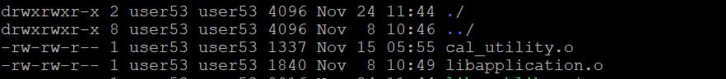

3. Create an executable using shared library.

A: gcc -o ./bin/app1 ./obj/cal_utility.o ./obj/libapplication.o---executable file app1 is created

To run-----./app1

4. Execute the application created step 3.

